

**PRASDES**

**Institutional Framework**

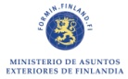logo INAMHI.png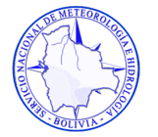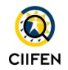 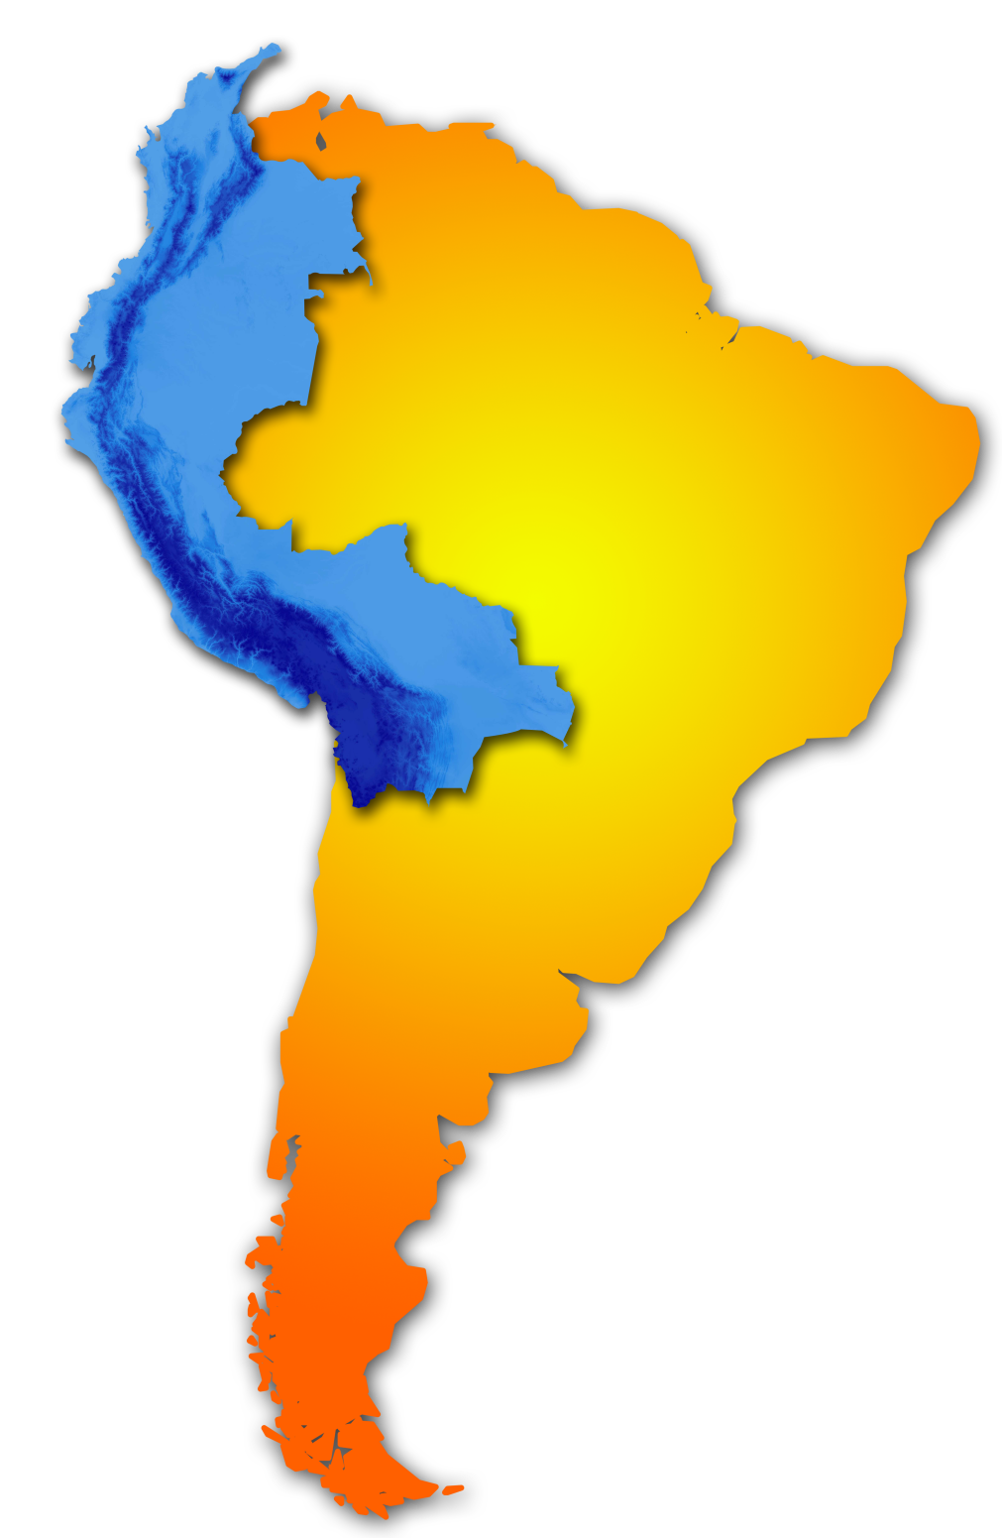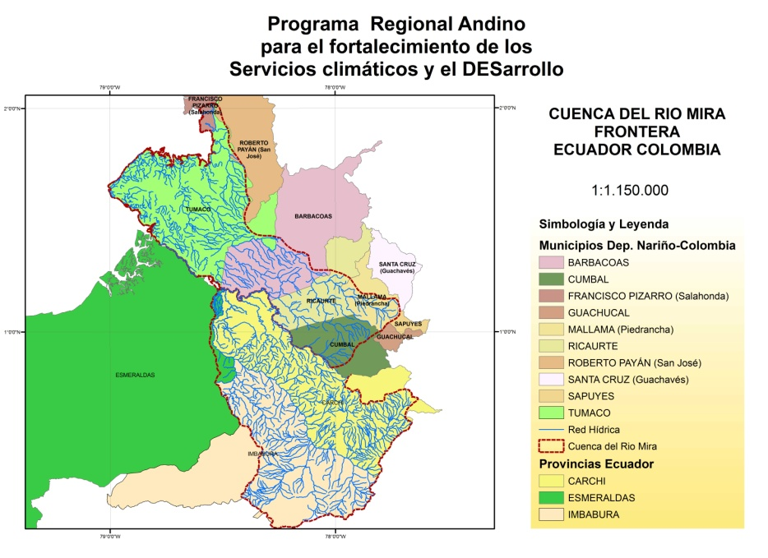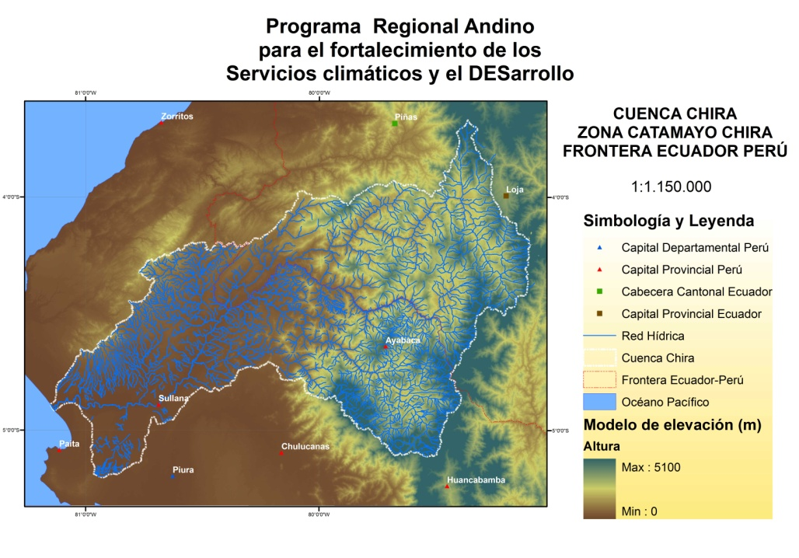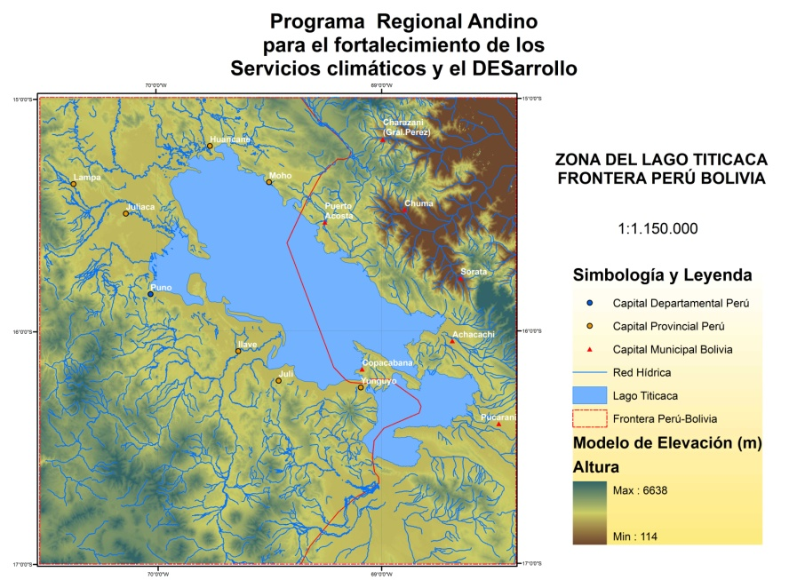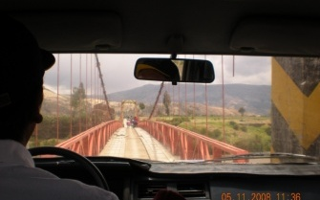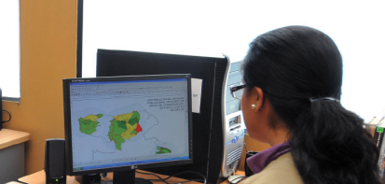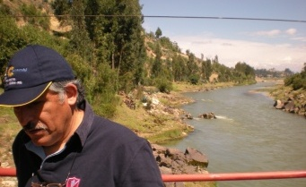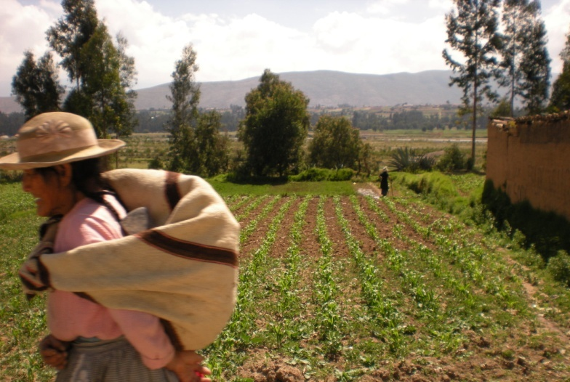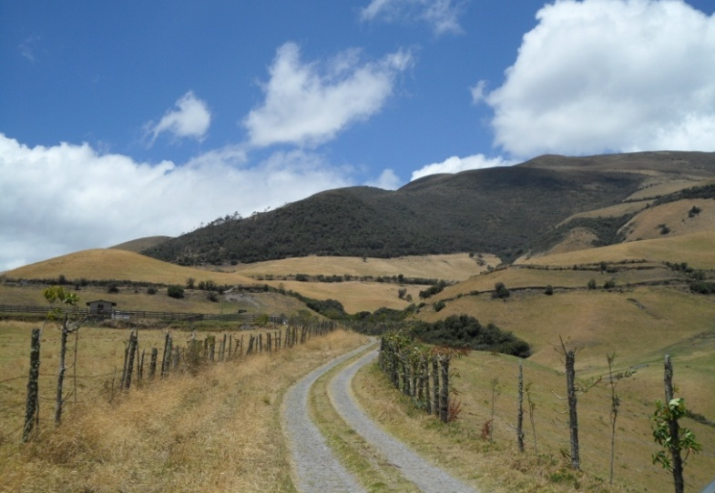

In Cooperation with :

Implemented by

Executed by

***The Regional Andean Programme to Enhance Climate Services and Development***

**Contact Information**

NAME

MAIL

WEB

**Pr**ograma **R**egional **A**ndino para el fortalecimiento de los **S**ervicios climáticos y el **DES**arrollo

*Gender Equality, Reduction of Inequality and Climate Sustainability*

**The development of a territorial approach to the way NMHSs services are provided in response to the needs of key development sectors, risk management systems and vulnerable communities is an area of particular interest to all four NMHSs.**

Specific training will be provided into the development of the NMHSs services in two contrasting cross-border catchment areas. These selected areas support new opportunities to develop cross-border forecasting, predictions and warnings that is fully in the spirit of promoting regional integration, cooperation and peace. This cross-border water catchment approach to be developed within the NMHSs aims at establishing **APSE** in which the goal is to support a more sustainable approach to regional/provincial sector planning and risk management as well as ensure the local population is prepared and aware of abnormal weather events (including climate variability and change) that could have a major impact on economic and social activity as well as deplete the natural resources base in the short and/or long-term.

**Territorial Approach**

**APSE 1: The Lake Titicaca Catchment Area (Puno-La Paz departments in Peru and Bolivia)**

**APSE 2: The Catamayo-Chira Upper and middle river basin (Loja province-Piura department in Ecuador and Peru).**

**APSE 3: Carchi-Guáltara and Mira-Mataje Catchment**

Beneficiaries

Two groups of key beneficiaries have been identified in PRASDES.

•Vulnerable communities located in the Pilot areas for extended services implementation (Áreas Piloto para Servicios Climáticos extendidos -APSE) who need accurate forecasting, predictions and early warnings to safeguard their land, assets and economic activities from both extreme weather phenomena and climate variability and change

•Risk Management Systems who need accurate forecasts, predictions and warnings to develop early warning systems and execute disaster prevention and reduction strategies agreed at the local, national, regional level such as the EAPAD and globally in line with the aims of the Hyogo Framework of Action.

**Programme Objectives**

General Objective

To contribute on sustainable human activity by reducing vulnerability to imminent and long-term climate related hazards through the efficient use of hydrological, meteorological and climatological information in the Andean region

Specific Objective

Strengthen the capacity of the National Hydrological and Meteorological Services (NMHSs) in the Andean Region to provide high quality hydrological, meteorological and climatic information and services in response to the needs and demands of strategic development sectors, risk management systems and vulnerable communities at regional, national and local levels

**Expected Results**